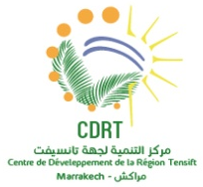
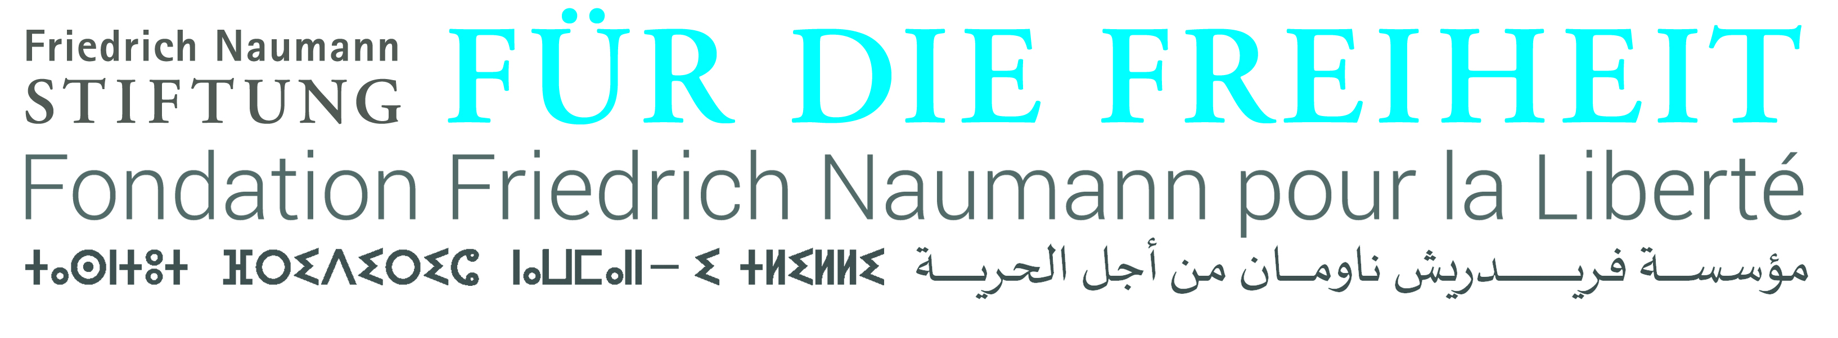
Second university of young leaders of African civil society
Call for proposals: CSO-led sessions
Deadline: 14 June 2019

The Regional Center of Development (Marrakesh region-Morocco) is pleased to launch a call for proposals for CSO-led sessions that will be taking place during the 2019 University of Young Leaders from African civil society. The university’s theme is “Youth, innovation and development in Africa”
The university will be held in Polytechnic University Mohamed VI- Marrakesh region.
Application will be reviewed by the CDRT-Committee. Selection criteria will include:

- alignment to the theme,
- gender balance,
- geographic representation
- diversity
- innovative, and
- solution-oriented

All proposals for CSO-led sessions should be submitted by email to associationcdrt@gmail.com, using the form below, duly completed.

Deadline for submission: Friday June 14, 2019, 17 H 00 GMT

Please note that we will not be able to acknowledge all submissions. Only successful applicants will be contacted.

This university is sponsored by the Office Cherifien des Phosphates (Morocco), the Polytechnic Mohamed VI University (Morocco), the City Council of Marrakech (Morocco), The Friedrich Naumann Foundation (Germany) and the International Institute of Innovation for Development (Canada).

- Contact information on the organiser

Name
Organisation
Website
social media link
Country/Region covered
Email address
Phone number
WhatsApp number

- Information on the Session

Title of the session
Session objectives
Alignment to the general theme
Session description
Focus areas of the session
Session format
Expected audience

- Proposed panelists and moderator

Please use this template for the proposed moderator and panelists. Ensure that there are adequate panelists for the allocated time (90 minutes).

Proposed moderator | Name
 | Organisation
 | Email
 | Country
Proposed panelist 1 | Name
 | Organisation
 | Email
 | Country
Proposed Panelist 2 | Name
 | Organisation
 | Email
 | Country
Proposed panelist 3 | Name
 | Organisation
 | Email
 | Country
*Provide names of reserves for each moderator and/or speaker proposed

Please add any other information related to the proposed session and to your organization that you want to share with the review Committee (maximum 100 words)

The CDRT and its partners will provide accommodation and catering for the participants for the event period. We suggest that the candidate cover his (her).

